Brian Dones

Professor Labouseur

Database Management

April 20, 2015

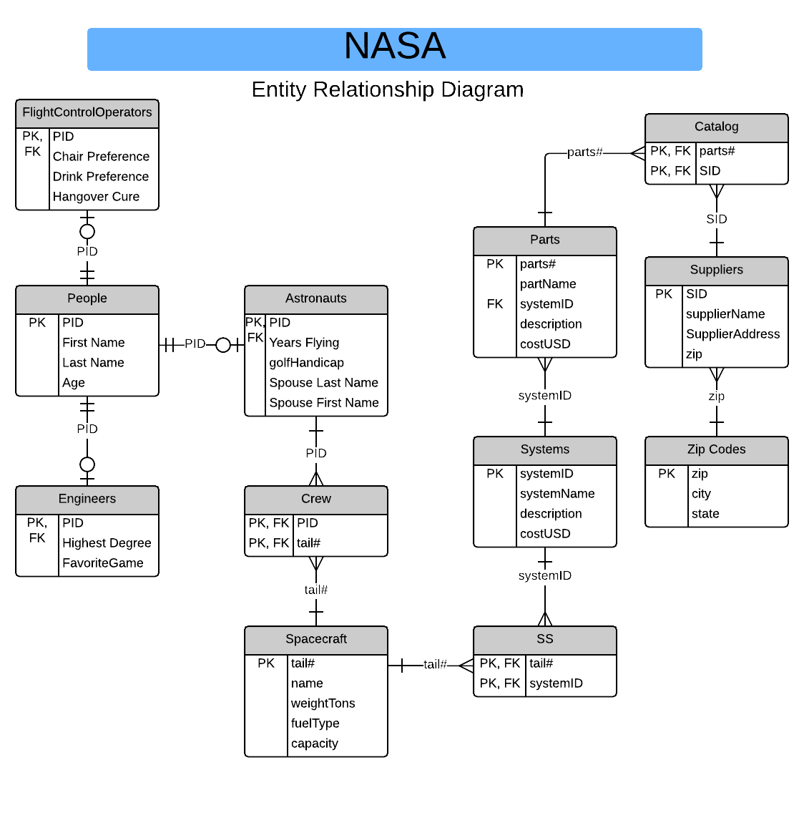

FlightControlOperators: PID → Chair preference, Drink Preference, Hangover Cure

People: PID → First Name, Last Name, Age

Engineers: PID → Highest Degree, Favorite Game

Astronauts: PID →Years Flying, golfHandicap, Spouses Last Name, Spouses First Name

Crew: PID, Tail # →

Spacecraft: Tail # → Name, weightTons, fuelType, Capacity

SS: Tail #, SystemID →

Systems: SystemID → System Name, description, costUSD

Parts: Parts # → Part Name, SystemID, description, costUSD

Catalogs: Parts #, SID →

Suppliers: SID → Supplier Name, Supplier Address, zip

Zip Code: Zip → City, State

This E/R Diagram is in 1NF because every column or attribute of data is atomic and does not contain more than one value or a grouping of attributes in one column. Along with 1NF, this diagram is also in 2NF because there are no multiple dependencies in each table and every non-key attribute can rely on the primary key of that table solely. The E/R Diagram is also in 3NF because there are no transitive dependencies in any of the tables. Nearly all tables are either described by one primary key or a composite key of two primary key columns with no non-key attributes.